Lab 11: Strings and Structures

Objective(s) : Upon completion of this lab session, learners will be able to:
- Able to use Strings
- Able to use several String functions
- Able to use Structure

Strings
The string is any sequence of characters. C++ strings allow you to directly initialize, assign, compare, and reassign with the intuitive operators, as well as printing and reading (e.g., from the user). to use strings, you need to include the header <string>.
Declaring string Objects
// declaring one object called str
string str;
// str1, str2, and str3 would be string objects
string str1, str2, str3;

Initializing string Objects
string str1 = "This is an example.";
string str2 = str1;

Reading a string input
//To read a single word:
cin >> str1;
//To read a single line of input:
getline (cin, st1);

String – Example

#include <iostream>
using namespace std;
int main ()
{
string greetings = "Hello Programmer :)"

cout << "Greeting message: ";
cout << greetings << endl;

return 0;
}

# Output
Greeting message Hello Programmer :)

String Functions Examples
substr ()
#include <iostream>
#include <string>
using namespace std;

int main ()
{
string str="We think in generalities, but we live in details.";

string str2 = str.substr (12,12); // "generalities"

cout << str2;

return 0;
}

# Output
generalities

replace ()
// replacing in a string
#include <iostream>
#include <string>
using namespace std;
int main ()
{
string base="this is a test string.";
string str2="n example";

cout << base.replace(9,5,str2); // "this is an example string."

}

# Output
this is a short phrase!!!
erase ()
#include <iostream>
#include <string>
using namespace std;

int main ()
{
string str ("This is an example sentence.");
cout << str << '\n';
// "This is an example sentence."
str.erase (10,8); // ^^^^^^^^
cout << str << '\n';
// "This is an sentence."
str.erase (str.begin()+9); // ^
cout << str << '\n';
// "This is a sentence."
str.erase (str.begin()+5, str.end()-9); // ^^^^^
cout << str << '\n';
// "This sentence."
return 0;
}

Output
This is an example sentence.
This is an sentence.
This is a sentence.
This sentence.

Structures

C++ arrays allow you to create different user defined data type, these data types are know as non-primitive data types or derived data type. i.e array, structures, enumeration and poitners. Array allow us to store similar data type elements in single variable. What if we need to combine differnty kind of data item in single variable. For this we have structures in C++. structure is another user defined data type which allows you to combine data items of different kinds.
Structures are used to represent a record, Suppose you want to keep track of mechanical parts in your inventory. You might want to track the following attributes about each part:
- Modelumber
- Partnumber
- Cost
Syntax of structure definition
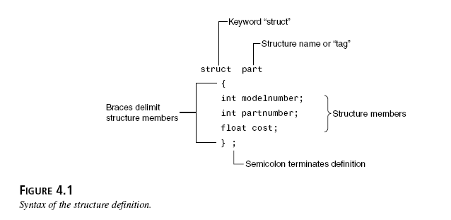

Structures – Example
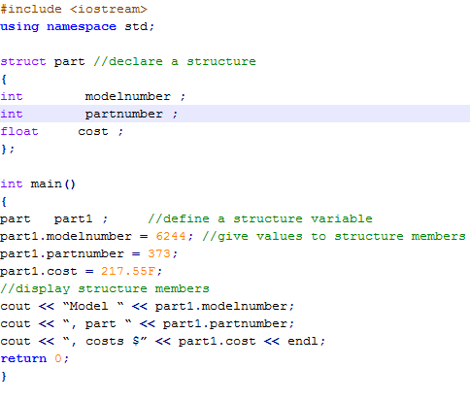

Output
Model 6244, part 373, costs $ 217.55

EXERCISES
Exercise 1
Write a C++ that contain two strings:
String1= “This program is to test several string functions”.
String2 = “Testing”
Perform following operations on these strings:
- Print a new string “Testing: This program is to test several string function” using concatenation of string 1 and strin2.
- Find the size of string1 and string2 using string function.
- Extract word “program” from string1 using string function.
- Insert a word “Program” in string2 like “Testing Program” using string function.
- Replace the word “Program” in string1 with string2 using string function.
Delete word “program” from string1 using string function
Exercise 2
Write a C++ program that maintain record of students. Student contains following details:
- ID
- Name
- Department
- Email
- Phone no
Create a structure of student. Ask user to enter record for 5 students. Store those details in variables of students type. Print those records on screen.
Exercise 3
Write a C++ program to do the following:
- Set up a structure/record to store products; each product has a name, a model number and a price.
- Choose appropriate types for these fields.
- Your program should contain a loop which allows entry via the keyboard of up to 10 products, to be stored in an array.
- The loop can be stopped by entry of "quit" for the product name
- Your program should include a function to display all the products details after the entry loop has finished.

Exercise 4
Write a C++ program that compute Net Salary of Employee. Program contains two user defined functions empSalary() and display().
- Create a structure of Employee that contains following data members:
  - EmployeeNumber, Name, BasicSalary, HouseAllowance, MedicalAllowance,Tax, GrossPay and NetSalary
- Employeenumber,name and basicsalary must be taken input from the user.
- empSalary() compute salary with given criteria
  - HouseAllowence = 10% of BasicSalary
  - Medical Allowence = 5% of Basic Salary
  - Tax = 4 % of Basic Salary
  - GrossSalary = Basic+HouseAllowence+MedicalAllowence
  - NetSalary = GrossSalary – Tax
- display() for displaying details of Empolyee
#Sample Output
Enter the Employee Number :10129
Enter the employee name: Ahmed Ali
Enter the Basic Salary: 16500

*************************************
EMPLOYERS SALARY DETAILS
*************************************
Employee Number:10129
Employee Name: Ahmed Ali
Basic Salary: 16500
House Allowence:1650
Medical Allowence: 825
Gross Salary: 18975
Tax Deduction: 660
Net Salary: 18315

